**NETWORKING & SYSTEM ADMINISTRATION LAB**

**Name: Nikhil Jais**

**Roll No: 25**

**Batch: B**

**Date: 21-04-2022**

**Experiment No.: 6**

**Aim**

Familirization of basic linux commands.

**Procedure**

1. **read :** It is used to read the contents of a line into a variable.

# Syntax : read [name] Output :



1. **locate :** It is used to locate the files by name.

# Syntax : locate [filename] Output :



1. **locate -i v,txt:** Ignore case distinctions when matching patterns.

# Syntax : locate -i filename.txt Output:



1. **find :** It supports searching by file, folder, name, creation date, modification date, owner and permissions.

# Syntax : file filename.txt Output:



1. **grep is v.txt :** It is used to search text and strings in a given file. In other words, grep command searches the given file for lines containing a match to the given strings or words.

# Syntax : grep <word in txt file>< filename.txt> Output:



1. **grep -i is v.txt :** Ignores, case for matching.

**Syntax :** grep -i <word in txt file><filename.txt>

# Output:



1. **grep -v is v.txt :** This prints out all the lines that do not matches the pattern.

# Syntax : grep -v <word in txt file><filename.txt> Output:



1. **grep -A1 vishnu v.txt :** Prints searched line and lines after the result.

# Syntax : grep -A1 <word in txt file><filename.txt> Output:



1. **grep -B1 batch b v.txt :** Prints searched line and n line before the result

# Syntax : grep -B1 <word in txt file><filename.txt> Output:



1. **grep -C1 batch v.txt :** Prints searched line and n lines after before the result.

**Syntax :** grep -C1 <word in txt file><filename.txt>

# Output:



1. **cat h.txt | grep Vishnu vijayakumar :** It is used to search text and strings in a given file.

# Syntax : cat filename.txt | grep word in txt file Output:



1. **df :** df is used to display the amount of available disk space for file systems.

# Syntax : df Output:

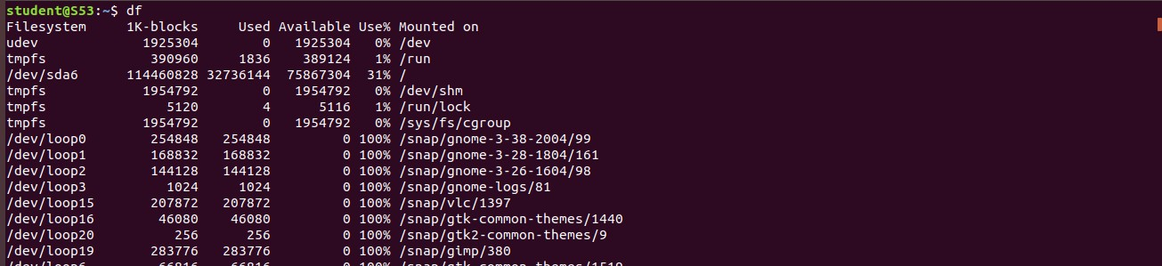

1. **df -m :** du is used to get report on a system in megabytes

# Syntax : df -m Output:

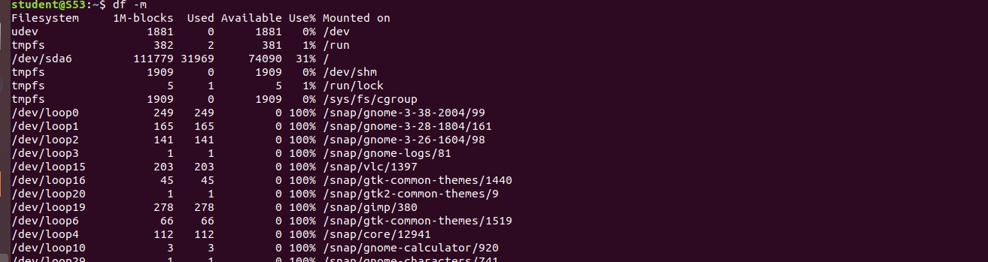

1. **du :** du is use to check directory/file ,space usage.

# Syntax : du Output:

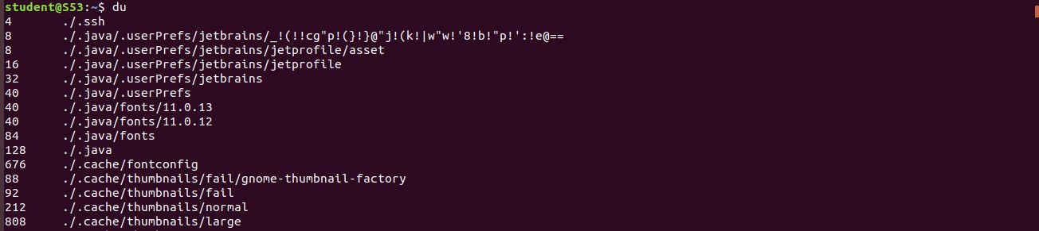

1. **wc :** wc stands for word count**.** It is used to find out number of lines, word count, byte and characters count in the files specified in the file arguments.

**wc -l v,txt :** This option prints the number of lines present in a file.

# Syntax : wc -l filename.txt Output :



1. **wc -w v.txt :** This option prints the number of words present in a file.

# Syntax : wc -w filename.txt Output:



1. **wc -c v.txt:** This option displays number of characters present in a file.

# Syntax : wc -c filename.txt Output:



1. **wc -m v.txt :** This option displays count of bytes present in a file.

# Syntax : wc -m filename.txt Output :

